Probability

Jon Thorson

Grades: 8-12

Pequot Lakes

[jthorson@isd186.org](mailto:jthorson@isd186.org)

Ali Murphy

8th grade

Bemidji

[alison_murphy@isd31.net](mailto:alison_murphy@isd31.net)

Joy Cooley

8th and 11th grade

New York Mills

[jcooley@nymills.k12.mn.us](mailto:jcooley@nymills.k12.mn.us)

Nicole Friend

Grades 7-12

Trek North

[nfriend@treknorth.org](mailto:nfriend@treknorth.org)

**Executive Summary:**

Probability and statistics is very important for all of our math learners. There are more and more fields that require a statistics class to be able to get a degree in that field. Knowing that students have varying background knowledge, readiness, interests, and preferences in learning, we plan to implement strategies that recognize and respond to this variety. You will find the following topics in this document: A two step probability problem, using an area model to represent the probability of an event, expected value and most likely outcome, looking at probability and odds, finding experimental and theoretical probabilities, finding combinations and permutations, looking at the probability of different colored M and M’s in a bag and an activity dealing with how black a zebra is. In all of our lessons students are working together and learning from each other. Below is an example of an MCA test question students will be able to answer after this unit. Standards are included on the next page.

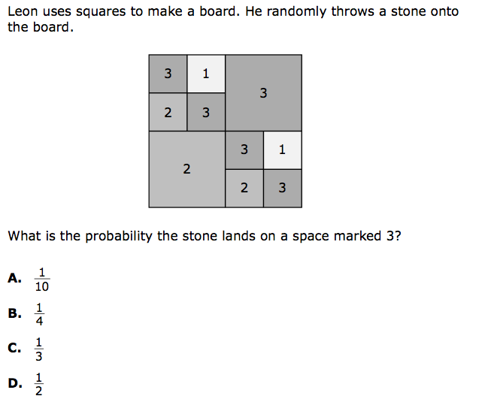

Standards

6.1.1.1 Locate rational numbers on a coordinate grid.

7.4.2.1 Use reasoning with proportions to display and interpret data in circle graphs (pie charts) and histograms. Choose the appropriate data display and know how to create the display using a spreadsheet or other graphing technology.

7.4.3.1 Use random numbers generated by a calculator or a spreadsheet or taken from a table to simulate situations involving randomness, make a histogram to display the results, and compare the results to known probabilities. For example: Use a spreadsheet function such as RANDBETWEEN(1, 10) to generate random whole numbers from 1 to 10, and display the results in a histogram.

7.4.3.2 Calculate probability as a fraction of sample space or as a fraction of area. Express probabilities as percents, decimals and fractions.

9.4.3.1 Select and apply counting procedures, such as the multiplication and addition principles and tree diagrams, to determine the size of a sample space and to calculate probabilities.

9.4.3.2 Calculate experimental probabilities by performing simulations or experiments involving a probability model and using relative frequencies of outcomes.

9.4.3.8 Apply probability concepts to real-world situations to make informed decisions.

9.4.3.9 Use the relationship between conditional probabilities and relative frequencies in contingency tables

Table of Contents

Day 1: How many of each color M and M is in a bag?

Day 2-3: Spinner activity with M and M’s theoretical probability

Day 4-5: Activity finding the probability of the number of M and M’s in a bag

Day 6: Money, Money, Money and Mia’s Cards

Day 7: One-and One, and sixty percent solution

Day 8: The Theory of 1-and-1 and streak-Shooting Shelly

Day 9-10: Race for the Pennant, Possible Outcomes, and How Likely is All "Wins"?

Day 11: Hospital Problem

Day 12: Probability a baby is a female or a male

Day 13: Showing how the square of a binomial ties into showing the probability of an event

Day 14-15 How black is a zebra?

Day 16 Introduction to Expected Value

DAY 17: How to calculate expected value

DAY 18: Creating a game and finding the expected value of the game.

Day 19: Probability in Contrast to Odds

Day 20: Payoff Odds of a fair game

**Lesson: M and M activity**

**Launch:** Click on the following link to introduce the activity of M&M’s

<https://www.youtube.com/watch?v=iapNZqTV7YQ> this video clip is from a Mars plant that makes M&M’s.

After the video explain that students will be doing an experiment with fun size packets of M&M’s.

*Prerequisite Knowledge: Students should have worked with degrees and a protractor and how to figure out an angle measure using the protractor.

*Standards:

7.4.2.1 Use reasoning with proportions to display and interpret data in circle graphs (pie charts) and histograms. Choose the appropriate data display and know how to create the display using a spreadsheet or other graphing technology.

7.4.3.1 Use random numbers generated by a calculator or a spreadsheet or taken from a table to simulate situations involving randomness, make a histogram to display the results, and compare the results to known probabilities. For example: Use a spreadsheet function such as RANDBETWEEN(1, 10) to generate random whole numbers from 1 to 10, and display the results in a histogram.

7.4.3.2 Calculate probability as a fraction of sample space or as a fraction of area. Express probabilities as percents, decimals and fractions.

**Explore and Share:** **Day 1**-Hand out the worksheet (taken from Teacherspayteachers.com) and explain the first page to the students. Grab one fun size bag of M&M’s and show how to tear off the top so students can use the bag for the experiment. Give students time to go through the activity. Once they have recorded their results, have students group into 3-4 and have them converge their results to one final tally. One person should bring up the results to the teacher and the teacher will put them into an excel sheet and show the class as a whole what the results conclude. Save this excel sheet for use in tomorrow’s class. Then have the students finish the activity worksheet.

**Day 2&3**-Today we are going to make a spinner. According to the M&M’s web site, each package of Milk Chocolate M&M’s should contain 24% blue, 14% brown, 16% green, 20% orange, 13% red, and 14% yellow M&M’s. Make a circle graph with this data. Students might need assistance trying to calculate the amount of the circle to shade for each color. The calculations should be based off the idea that a circle is 360 degrees and they need to multiply the percent (changed to a decimal) by 360. This will give the students the degrees needed to make each color. Next hand out a paper clip and have the students use a marker to mark a line on the paper clip. Have the students hold a pencil at the center of the circle with the paper clip and spin. Where the line is, is where the spinner lands.

Now have the students cast a vote of whether the data collect today will have the same results, different results, or about the same results as day 1. Then, have the students spin 12 times and record the data. Conduct the same experiment as day 1 and record the results for the whole class. Have a discussion about the results and compare them to day 1. What was different? Why was it different? Was it the same? Why did students cast their vote the way they did?

**Day 4:** Now that we know what should be in our bag of MM’s, lets figure how many of each color a person would typically have in each bag. Using the percentages from day 2 from the MM’s website, calculate the number of each color. Group students into partners and let them go through the worksheet. Walk around and make sure to answer some questions as you go.

**Day 5**: Have each student write down their name on a sheet of paper and put the paper in the bowl on the teachers table. Hand out the worksheet Show me what you have learned and let students work with a partner to answer the questions. After everyone is done, go through each question by choosing one name from the jar to explain and answer the question.

**Summarize:** This lesson packet focuses on probability and teaches students how to find probability using the idea that probability is what you want to happen divided by the total. Students should be able to calculate simple probabilities after this packet.

The worksheet below was taken from teachers pay teachers free downloads

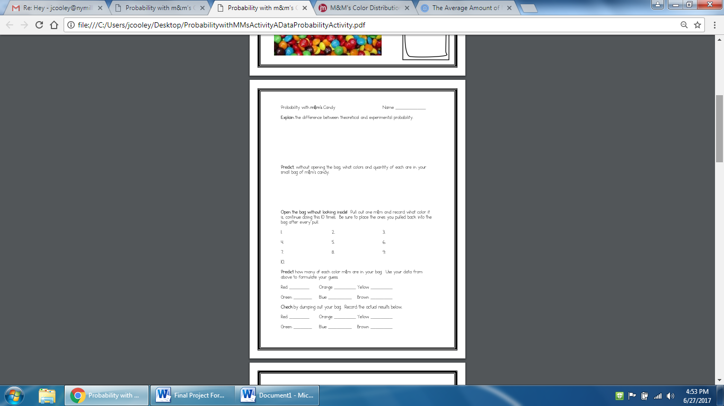

How close was your prediction to the actual result? Record the data for each color.

Red _____________ Orange _____________ Yellow______________

Green_____________ Blue________________ Brown______________

Explain and create a double bar chart of your results

**Day 4 Worksheet Names___________________________________**

Now that we know what should be in our bag of M&M’s, lets figure how many of each color a person would typically have in each bag. Using the percentages from day 2 from the M&M’s website, calculate the number of each color based off the fact that there should be 16 M&M’s in each bag.

M&M’s Website: 24% blue, 14% brown, 16% green, 20% orange, 13% red, and 14% yellow

How are you going to find the number of each color?

Record the number you think should be in each bag below

Red _____________ Orange _____________ Yellow______________

Green_____________ Blue________________ Brown______________

To find the theoretical probability we need two things. What we want to know and how many total there are.

The formula for probability looks like this What you want to happen

Total

Now calculate the theoretical probability of each color. Express each as a percent, fraction and decimal.

|  |  |  |  |
| --- | --- | --- | --- |
| Color | Percent | Fraction | Decimal |
| Red |  |  |  |
| Orange |  |  |  |
| Yellow |  |  |  |
| Green |  |  |  |
| Blue |  |  |  |
| Brown |  |  |  |

Now that you have calculated all your probabilities, let’s look at some problems.

1. If you reach into the bag, what should be the color you pick?_____________________
2. You reach into the bag and pick an orange? _____________
3. You reach into the bag and pick a yellow first, and then you replace the yellow and pull out a brown? _______________________________________
4. You reach into the bag and pick a Purple?__________________

**Show me what you have learned worksheet Names________________________**

Jane’s teacher starts each class with the names of all her students in a container. She chooses students to present answers by pulling out names at random. Once a name is choosen, it is set aside for the day, but then all the names are replaced for the next day. There are 12 girls and 6 boys in the class.

1. What is the probability Jane will be the first student chosen on Monday?
2. What is the probability Jane will be the first student chosen on Tuesday?
3. What is the probabilty Jane will be the first student chosen on both Monday and Tuesday?
4. What is the propability that a boy is chosen on any given day?
5. What is the probabilty that a girl is chosen on any given day?
6. Supposed Jane is chosen first, what is the probabiltiy that the next student chosen is also a girl?
7. Suppose the teacher randomly selects 6 students at random. Would you be surprised if 2 girls were chosen? Explain.

Mary wants to know what students think about replacing the candy in two vending machines in the cafeteria with more healthful snacks. There are 300 sixth graders, 300 seventh graders, and 200 eighth graders. Half of the students in each grade are girls. Mary obtains a list of student names grouped by grade, with the girls listed first in each grade. Use this information to answer the questions

1. Mary randomly chooses 3 different students from the list of 800 students.
   1. What is the probability that the first choice is a girl? The second choice is a girl? The third choice is a girl?
   2. What is the probability that Mary chooses three girls?
2. Mary decides to choose one person from each grade at random.
   1. What is the probability that her sixth grade choice is a girl?
   2. What is the probability that she chooses three girls?
3. 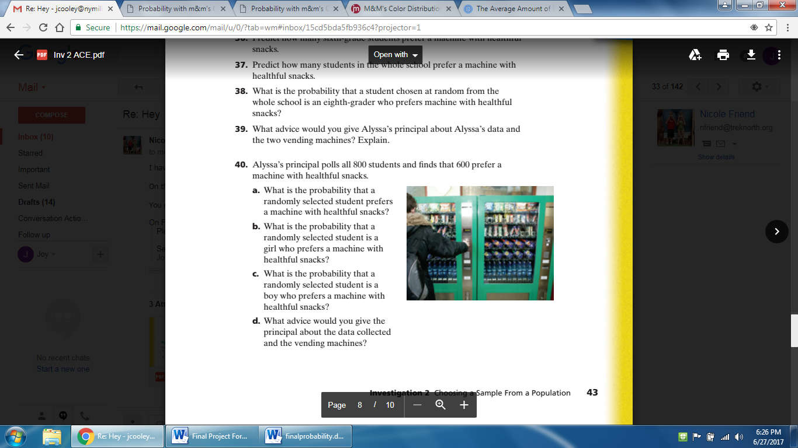

Questions are Taken from Connected Mathematic 2

**Pre/Post Test Name_____________________________**

1. Which of the following is an impossible event?

A. choosing an odd number from 1 to 10.

B. getting an even number after rolling a single 6-sided die.

C. choosing a white marble from a jab of 25 green marbles.

D. none of the above

|  |
| --- |
| **2.** A jar contains five red, three green, two purple and four yellow marbles. A marble is chosen at random from the jar. After replacing it, a second marble is chosen. What is the probability of choosing a purple and a red marble?  A. 5/98  B. 1/2  C. 3/98  D. 2/49 |
| 3. At Pacific Middle School, 3 out of 5 students make honor roll. What is the probability that a student does not make honor roll?  A. 65%  B. 40%  C. 60%  D. None of the above | |

4. A quality inspector examines a sample of 25 strings of lights and finds that 6 strings of lights are defective. What is the best prediction of the number of defective strings in a delivery of 1000 strings of lights?

A. 6 lights

B. 25 lights

C. 24 lights

D. 240 lights

5.



Answers:

1. C
2. A
3. B
4. D
5. D

Taken from MN MCA 7th grade item sampler on the scimathmn frameworks website.

**Special Note: The following materials are copyright from IMP Year 1, Second Edition, The Game of Pig unit and IMP Year 3, Second Edition, Pennant Fever unit.  In the interest of trying to stay within the fair use of copyrighted materials, the student pages have been cropped and screen-shot into this lesson set.**

**Money, Money, Money**

**Objectives:** Students will examine a two-step [probability](http://impmoodle.its-about-time.com/mod/glossary/showentry.php?courseid=2&concept=probability) problem.

Standards: 9.4.3.1, 9.4.3.2, 9.4.3.8, 9.4.3.9

**Launch:**

The two situations posed in this activity are two-step probability problems. If students are able to visualize the possible outcomes using an [area model](http://impmoodle.its-about-time.com/mod/glossary/showentry.php?courseid=2&concept=area+model), it is likely they will be able to apply the techniques they have acquired to build an [area](http://impmoodle.its-about-time.com/mod/glossary/showentry.php?courseid=2&concept=area) model. Have students do this activity individually. During their work or the discussion, students should recognize that the two situations posed in this activity have a two-stage aspect to them that can be represented by the two-dimensional nature of a rug diagram (area model).

**Explore:**

For Question 1, students may see that it makes sense to set up the diagram with the result of one coin across the top and the result of the other coin down the side. With this diagram, they can show that the three outcomes Nina describes are not equally likely.

For Question 2, you can move students toward a diagram like the one below. This may not be the most obvious representation for some students, so expect the need for some clarification. You might ask, "**What could happen if the $1 bill is pulled from the left pocket?" How can the column showing the likelihood of drawing $1 be divided to show the three possible bills drawn from the right pocket?**

|  |  |  |  |  |
| --- | --- | --- | --- | --- |
|  |  | **Left pocket** | | |
|  |  | $1 bill | $5 bill | $10 bill |
|  | $1 bill | $2 | $6 | $11 |
| **Right pocket** | $5 bill | $6 | $10 | $15 |
|  | $10 bill | $11 | $15 | $20 |

Students will probably see that each of the nine boxes is equally likely, and they can then find the probabilities.

Rather than explicitly discuss Question 3, you may just want to suggest that students incorporate the methods used in this activity into their two-dice sum analyses, looking for ways to represent equally likely outcomes.

**Summarize:**

Key Questions-

What could happen if the $1 bill is pulled from the left pocket? How can the column showing the likelihood of drawing $1 be divided to show the three possible bills drawn from the right pocket?

From a probability perspective, is it the same or different to draw $5 from my right pocket followed by drawing $1 from my left pocket as it is to draw $5 from the right and $1 from the left?

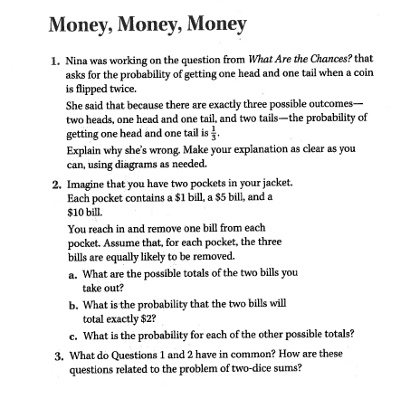

**Mia’s Cards**

**Objectives:**

Students analyze another probabilistic situation involving a payoff by considering a large number of trials. In the discussion of the activity, they are introduced to the [term](http://impmoodle.its-about-time.com/mod/glossary/showentry.php?courseid=2&concept=term) [*expected value*](http://impmoodle.its-about-time.com/mod/glossary/showentry.php?courseid=2&concept=expected+value).

Standards: 9.4.3.3, 9.4.3.5

**Launch:**

Students work individually on the activity and then come together to share methods and ideas. The teacher then introduces the term *expected value* for the concept of computing an [average](http://impmoodle.its-about-time.com/mod/glossary/showentry.php?courseid=2&concept=average) per turn over the long run. Students will connect the concept to previous work in the unit and to the unit problem: finding the strategy for the game of Pig that gives the highest expected value.

**Explore:**

Have students share their results in groups. Presentations of solutions to Questions 1 and 2 can help students feel comfortable working with a large number of games, finding the total number of points, and then finding the average by dividing by the number of games.

Presentations that use different numbers of games will help dramatize the point that the average will be the same. For example, in Question 1, using 100 games gives Mia about 25 hearts, for 250 points, and about 75 cards from the other suits, for 375 points. Using 500 games gives her about 1250 points from hearts and 1875 points from the other suits, for a total of 3127 points. Each total gives an average of about 6.25 points for each card picked.

Introduce the term expected value for “the average amount gained (or lost) per turn in the long run.” Ask students to restate their results from Questions 1 and 2 using this term. For instance, for Question 1, students might say that Mia has an expected value per turn of 6.25 points. (For emphasis, it’s a good idea to use a phrase like *per game* or *per turn* whenever you use the term *expected value*.)

If students are having difficulty, use some of the games they made up for Question 3 to solidify the idea. Even if they seem comfortable with the concept of expected value, you might ask groups to share some of their games and have the class figure the expected value of each game.

If students haven’t already made the connection between the concept of expected value and the game of Pig, you might ask, “How can you restate the unit problem in terms of expected value?” Help students to realize that they are looking for the Pig strategy that gives the highest expected value. Edit or add to the posted unit goal to reflect this use of the term.

**Summarize:**

If students haven’t already made the connection between the concept of expected value and the game of Pig, you might ask, How can you restate the unit problem in terms of expected value? Help students to realize that they are looking for the Pig strategy that gives the highest expected value. Edit or add to the posted unit goal to reflect this use of the term. Does an expected value of 6.25 points per turn mean that Mia will get 6.25points each time she draws a card? Can you rephrase other problems you have seen in terms of expected value? How can you restate the unit problem in terms of expected value?

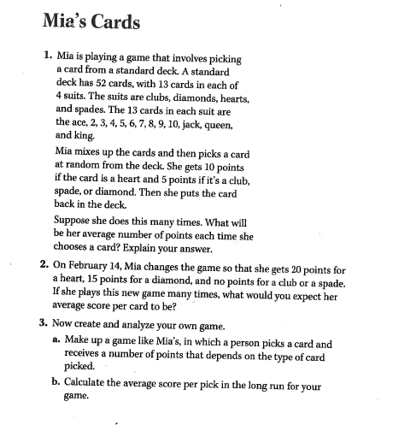

**One-and-One**

**Objectives:**

Students apply the concept of [expected value](http://impmoodle.its-about-time.com/mod/glossary/showentry.php?courseid=2&concept=expected+value) to this new situation, this time in relation to *most likely* [*outcome*](http://impmoodle.its-about-time.com/mod/glossary/showentry.php?courseid=2&concept=outcome). They conduct simulations as well.

Standards: 9.4.3.2, 9.4.3.8

**Launch:**

This activity introduces the one-and-one free throw context, which is used in the next several activities. Students first guess how many points they think are most likely for a one-and-one free throw shooter to make and then design a simulation to test their guesses. In the next activity, *The Theory of One-and-One,* students develop theoretical methods to analyze their initial guesses.

**Explore:**

Ask whether anyone can explain what a one-and-one situation is in basketball. A one-and-one occurs in a penalty situation in which one player has committed a foul against another. The player who has been fouled is allowed to take a free throw. If the free throw is unsuccessful, the one-and-one situation is over. If the first shot is successful, the player gets to shoot once more. Each successful shot scores 1 point. The player can thus score a total of 0 points (by missing the first shot), 1 point (by making the first shot but missing the second), or 2 points (by making both shots).

Once students understand the one-and-one situation, have them read the problem described in *One-and-One*, in which Terry has a 60% chance of success on each attempted free throw. Clarify the meaning of this by asking how many shots Terry would be likely to make out of 100, out of 40, out of 15, and so on.

Then have students, working individually, consider the question posed in the activity: **In a one-and-one situation, how many points is Terry most likely to score: 0, 1, or 2?** When they have thought about the question, conduct a class vote, recording the number of students who select each possible score.

Tell students that they will now design and conduct an experiment to estimate the probabilities involved in the situation. Introduce the word **simulation.** Ask, **Where have you heard the word simulation before?** (One example is flight simulators.) **Why do people use simulations?** The main idea that should emerge is that a simulation allows us to learn about something when we can’t investigate that thing directly. You might also ask, **Have you done any simulations for other mathematics problems in this unit?** Students might mention their current work on *POW: What’s on Back?*

Ask students to describe the difference between finding [probability](http://impmoodle.its-about-time.com/mod/glossary/showentry.php?courseid=2&concept=probability) using experimental results and using a theoretical analysis. They should be growing more comfortable articulating that an experiment can give them a feel for what the results might be, while a simulation will give only observed probabilities, which can at best approximate theoretical probabilities, even with a large number of trials.

Give students the paper bags and cubes and ask, **How might you use these materials to set up a simulation to study the question in this activity?** Alternatively, you might ask students to design a simulation without prompting them with specific materials. They might suggest using other objects or propose using a [random](http://impmoodle.its-about-time.com/mod/glossary/showentry.php?courseid=2&concept=random) number generator.

If students suggest using 60 cubes of one color and 40 of the other, ask whether there is a smaller number of cubes that would work. Some students will identify 3 and 2; others will be more comfortable with 6 and 4. Focus on why the particular combinations they identify are appropriate. Ask, **Why is this combination of cubes suited to this problem?** Students should be able to articulate that if 60% of the cubes are red, picking a red cube represents making a free throw and picking a yellow cube represents missing a free throw.

It’s a good idea to have students try to describe exactly how they will conduct the simulation. For example, they might construct instructions like these:

Shake the bag and pull out a cube. If the cube is yellow, the simulation is over. Write 0 for the score. If the cube is red, draw again to complete the simulation. (Return the red cube to the bag and shake before drawing again.) If the second cube is yellow, write 1 for the score. If the second cube is red, write 2 for the score.

Conduct a few simulations as a class, and then have students work in pairs. Each pair should simulate the one-and-one situation approximately 20 times, recording each result, to gather lots of data for the class to examine. When they are finished, have each pair tally the number of 0s, 1s, and 2s they got.

**Summarize:**

Compile a class total of the 0s, 1s, and 2s from the simulations. As a class, calculate the percentage of the time each score occurred. If the theoretical probabilities are borne out, the experiment will have produced more 0s than any other number. (However, 2s are a close theoretical second.)

Typically, most students will have guessed that a score of 1 is the most likely. This conversation will be continued in the discussion of *Theory of One-and-One,* when students observe that the expected value per one-and-one situation is very close to 1, even though the score of 1 is actually the least likely result.

Ask, **Do you think the simulation is a good method for analyzing the situation?** Tell students that they will later use an [area model](http://impmoodle.its-about-time.com/mod/glossary/showentry.php?courseid=2&concept=area+model) as a theoretical model to analyze the situation.

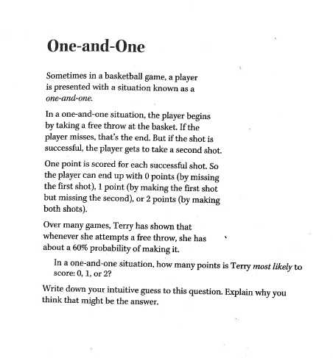

**A Sixty Percent Situation**

**Objectives:**

The discussion of students’ simulations may bring forth the notion that as more experiments are conducted, the outcomes tend toward the theoretical probabilities. The activity also indirectly inquires about the [expected value](http://impmoodle.its-about-time.com/mod/glossary/showentry.php?courseid=2&concept=expected+value)—preparing students to wrestle with the difference between “average over the long run” and “most likely to occur.”

Standards: 9.4.3.1, 9.4.3.2, 9.4.3.3

**Launch:**

This activity should be done individually, followed by a brief whole-class sharing and discussion of results. The activity is very similar to students’ work in *One-and-One* and sets the stage for developing methods to figure two-stage probabilities in *The Theory of One-and-One.*

**Explore:**

Ask a few volunteers to report their results. Then ask, Was the average score you found also the most likely result? Although the majority of students should have found that Terry’s most common result was 0 or 2, most should also see that the average for 40 trials is quite close to 1.

Ask students how they could state the results for Question 4 in terms of expected value. They should see that the answer to Question 4 is an experimental estimate of Terry’s expected value for each one-and-one situation.

**Summarize:**

Key Questions: What results did you get?Was the average score you found also the most likely result?Can you state the results for Question 4 in terms of expected value?

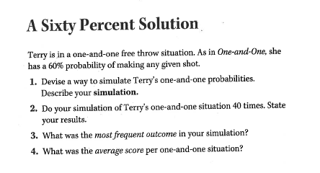

**The Theory of One-and-One**

**Objectives:**

The theoretical analysis of the one-and-one situation continues to develop students’ understanding of expected value—not only its computation, but also its meaning as an [average](http://impmoodle.its-about-time.com/mod/glossary/showentry.php?courseid=2&concept=average) over the long run, as opposed to what is most likely to occur. Students also continue their use of the [area model](http://impmoodle.its-about-time.com/mod/glossary/showentry.php?courseid=2&concept=area+model) as a tool to figure the probabilities of a multistage event. This understanding of [probability](http://impmoodle.its-about-time.com/mod/glossary/showentry.php?courseid=2&concept=probability) and expected value will be used in the final analyses of the games of Little Pig and Pig itself.

**Standards:** 9.4.3.1, 9.4.3.2, 9.4.3.3, 9.4.3.8

**Launch:**

Students will begin this activity in groups. When some groups have completed the activity, the class will come together to share ideas about techniques and the answers they yield.

**Explore:**

Students have completed an experimental analysis of the one-and-one situation. Now they will work in groups to develop a rug diagram analysis of Terry’s expected value for each one-on-one situation. (You may want to begin using the [term](http://impmoodle.its-about-time.com/mod/glossary/showentry.php?courseid=2&concept=term) area model in place of *rug diagram*.)

You may need to help groups get started. One useful and familiar way to begin this analysis is to consider a large, convenient number of cases. The shooting probabilities are reported as percents, which can suggest imagining 100 cases. Consider a large number of one-and-one situations, such as 100. In those 100, Terry would make 60 of her first shots. Can you show that in a rug diagram? What does this rug diagram mean so far? What do you need to do next?

Some students may find it useful to work with [graph](http://impmoodle.its-about-time.com/mod/glossary/showentry.php?courseid=2&concept=graph) paper, using a 10-by-10 section to represent 100 shots. If they do use graph paper, be aware that later problems may not lend themselves so nicely to whole-number solutions, so students should also work with more schematic diagrams that encourage the computation of multistep probabilities by figuring area through multiplication and addition rather than by counting squares.

Some students may not know how to proceed, especially if they are thinking about each individual one-and-one situation. If so, you might ask what would happen in the cases in which Terry makes her first shot. When Terry gets the opportunity to attempt a second shot, what portion of the time will she make this shot? How will you show this in your area model? As you circulate, you may want to identify one or two groups whose members seem to have a clear understanding of the process and ask them to prepare presentations. In this case, presenters may be more able to share their thinking about how they designed their area models if they begin with unmarked rugs and talk through each decision in their analyses.

**Summarize:**

Ask one or two groups to present their work by demonstrating each step of their analyses and how it gets incorporated into their area models. Emphasize the arithmetic of finding the portion of the total area for the various sections. For example, if students use a diagram like the one shown above, they will need to figure out that the “2 points” section represents 36% of the total area, because it is 60% of 60%.

As groups present their diagrams, they should note that each section contains both

* The number of cases (or portion of the area) that it represents
* The number of points scored for each case

If the diagram is drawn on a 10-by-10 grid, each box would represent a single one-and-one situation, and students would be able to find areas by counting boxes.

By considering both the number of cases and the point value for each section, students should come up with an analysis that is something like this, which is based on 100 cases:

* 40 cases worth 0 points each
* 24 cases worth 1 point each
* 36 cases worth 2 points each

Thus 100 cases give a total of

(40 • 0) + (24 • 1) + (36 • 2) = 96 points

So, the average number of points per one-and-one situation is 0.96. This analysis also confirms that a score of 0 points is most likely (40% of the time), a score of 2 points is next most likely (36% of the time), and a score of 1 is least likely (24% of the time).

This analysis can be done without the use of an area model by simply analyzing what might happen in a large number of cases. But the combination of the geometric and arithmetic perspectives is generally helpful for students, and the technique of subdividing cases or area portions will be useful in analyzing the game of Pig.

This is a good time to reemphasize that the average result is the same no matter how many cases are considered. For instance, considering a total of 1000 one-and-one situations would give a total of 960 points, resulting in the same average of 0.96 point per one-and-one situation. You might mention that *expected average* might be a better term for this concept, but that *expected value* has become standard.

The rug diagram can help students confirm that the most likely score (which is 0) is not the expected value (which is very close to 1). The diagram might also provide insight into the misguided intuition that these values are the same, because some students can see in the diagram something “1-like” about the problem. Ask, What’s the difference between *expected value* and *most likely* [*outcome*](http://impmoodle.its-about-time.com/mod/glossary/showentry.php?courseid=2&concept=outcome)? Stress that these two ideas are different, although often confused.

**Streak-Shooting Shelly**

**Objectives:**

This activity involves [conditional probability](http://impmoodle.its-about-time.com/mod/glossary/showentry.php?courseid=2&concept=conditional+probability), in which the [probability](http://impmoodle.its-about-time.com/mod/glossary/showentry.php?courseid=2&concept=probability) of the [outcome](http://impmoodle.its-about-time.com/mod/glossary/showentry.php?courseid=2&concept=outcome) at one stage depends on the outcome of a previous stage. The mathematical goal is to deepen students’ intuition about and analytic ability to work with probability rather than to derive formal algorithms or computation methods.

**Standards:** 9.4.3.1, 9.4.3.2, 9.4.3.3

**Launch:**

After individually exploring the multistage probabilistic situation posed, students will share approaches. The activity concludes with the naming of this type of problem as a question of conditional probability.

**Explore:**

Prior to assigning this activity, you might help students recall that their initial approach to analyzing the situation in *The Theory of One-and-One* was to consider a large number of trials and draw an [area model](http://impmoodle.its-about-time.com/mod/glossary/showentry.php?courseid=2&concept=area+model). Ask for volunteers to present their results. Elicit at least one presentation involving [area](http://impmoodle.its-about-time.com/mod/glossary/showentry.php?courseid=2&concept=area) models. Area models provide a visual representation of what is happening and can help many students reason through multistage probability problems. Students might use a [sequence](http://impmoodle.its-about-time.com/mod/glossary/showentry.php?courseid=2&concept=sequence) of diagrams to describe the stages of the situation.

Thus, Shelly scores no points 20 times, one point 8 times, and two points 72 times. Confirm that   
20 + 8 + 72 = 100.

In answer to Question 1, the diagram shows that she scores no points 20% of the time, one point 8% of the time, and 2 points 72% of the time.

**Summarize:**

Explain that this situation is an example of conditional probability, since the probability of Shelly making a free throw depends on when it comes in the shooting sequence.

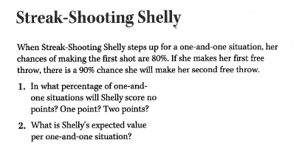

**Race for the Pennant!**

**Objectives:**

The central unit problem is to find the probability that a team called the “Good Guys” will win the baseball pennant, given a situation in which all but two teams are out of the running.

Standards: 9.4.3.1, 9.4.3.5, 9.4.3.7, 9.4.3.8

**Launch:**

Students work on the activity in groups, and then discuss as a class their work and simplifying assumptions for the unit problem. Small groups, followed by whole-class discussion.

**Explore:**

Tell students that the central unit problem involves finding the probability that a certain baseball team, called the “Good Guys,” will win the pennant. In the context of this unit, *winning the pennant means* “winning more games than any other team.”  
  
Neither you nor your students need to know any details about the game of baseball to work on this problem, but it will give some students a sense of ownership of the problem if they have an opportunity to share their knowledge of baseball. Try to allow some students to share their knowledge without overwhelming other students with unnecessary information.  
  
Have students read the introduction to the problem (stop before the questions), and then be sure everyone understands the basic scenario. Here are the important details:

* The Good Guys are leading, near the end of the season, and their closest competitor is the Bad Guys.
* All other teams in the league are so far behind that they don’t have a chance.
* The Good Guys will not play against the Bad Guys in any of their remaining games of the season.
* The winner of the pennant is the team that wins the most games. (The situation in major league baseball today is more complicated, because the pennant involves playoff games between division winners.)

Clarify, if necessary, that an individual game cannot end in a tie. Then have groups work on the questions in the activity.

**Summarize:**

Unless you observed groups having difficulty with Question 1, begin the discussion by having several students present their groups’ ideas about Questions 2 and 3. Encourage students to challenge each other’s reasoning and to engage in productive debate. Be sure that presenters state their assumptions clearly.  
  
On Question 2, students are likely to reason that the teams are each most likely to win about four of their remaining seven games, because that is roughly the proportion of games they won previously. (If students present the actual percentages of games won so far for each team, save those values for discussion later today.)  
  
Question 3 is more complex and is the central problem of the unit. If students seem tentative, ask, Can you say anything about the probability? Is there a range within which it must fall? For instance, they can be fairly sure that it is greater than (and, of course, less than 1). Here are some reasons they might give for this [conclusion](http://impmoodle.its-about-time.com/mod/glossary/showentry.php?courseid=7&concept=conclusion):

* The Good Guys are now ahead of the Bad Guys, so they need fewer wins to end up ahead. Thus, they are more likely to win the pennant than the Bad Guys are.
* The Good Guys are probably a better team, because otherwise they wouldn’t be ahead now. Therefore, they have a better chance of doing well in their remaining games than the Bad Guys do.

Tell students that this problem is quite complicated and that solving it will be the main [focus](http://impmoodle.its-about-time.com/mod/glossary/showentry.php?courseid=7&concept=focus) of this unit. Acknowledge that in real life, many issues beyond mathematics would go into determining the probability that the Good Guys would win the pennant, such as which teams the Good Guys and Bad Guys were playing in their remaining games and how healthy their players were.

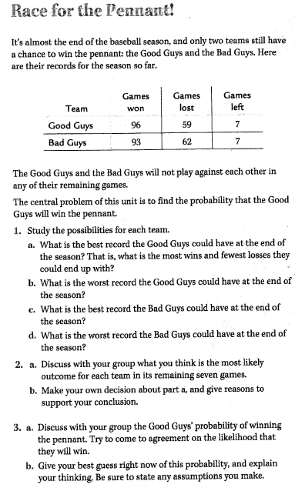

**Possible Outcomes**

**Objectives:**

*Possible Outcomes* provides practice with systematically listing the various cases in a complex situation: students list all of the possible records that each of the two teams in the unit problem might have for the remaining seven games, and then enumerate the possible combinations of records for the two teams together. The activity also establishes the multiplication principle for the number of ways to pick one object from each of two sets.

Standards: 9.4.3.8

**Launch:**

Students should be able to complete this activity independently.

**Explore:**

Students should see that there are eight possibilities for each team, because the number of their wins can be any integer from 0 through 7. (Some students may get seven possibilities by forgetting 0; clarify this situation as needed.) They should also see that having eight possibilities for each team means that there are 64 possible combinations.  
  
Have a volunteer share his or her display for Question 3b. If students have alternative ways to present the combinations, let them share these ideas. A display like the one below is a particularly effective way to show all combinations. The individual boxes within this chart can be referred to as *cells*. In this display, a “G” in a cell indicates that the Good Guys win the pennant if that [combination](http://impmoodle.its-about-time.com/mod/glossary/showentry.php?courseid=7&concept=combination) occurs, a “B” means the Bad Guys win, and a “T” means a tie (that is, the two teams end up with identical records for the season). Provide a copy of this chart (the *Possible Outcomes* [blackline master](http://impmoodle.its-about-time.com/file.php/7/Pennant_PDFs/Possible_Outcomes_BLM.pdf)) to each student; it has space for students to write in the probability of each combination as it’s found throughout the unit. You may also want to post a master copy of the chart in the classroom and fill in probabilities as students find them.

**Good Guys' record for the final seven games**

|  |  |  |  |  |  |  |  |  |  |  |
| --- | --- | --- | --- | --- | --- | --- | --- | --- | --- | --- |
|  |  |  | 7-0 | 6-1 | 5-2 | 4-3 | 3-4 | 2-5 | 1-6 | 0-7 |
| **Bad** |  | 7-0 | G | G | G | T | B | B | B | B |
| **guys'** |  | 6-1 | G | G | G | G | T | B | B | B |
| **record** |  | 5-2 | G | G | G | G | G | T | B | B |
| **for** |  | 4-3 | G | G | G | G | G | G | T | B |
| **final** |  | 3-4 | G | G | G | G | G | G | G | T |
| **seven** |  | 2-5 | G | G | G | G | G | G | G | G |
| **games** |  | 1-6 | G | G | G | G | G | G | G | G |
|  |  | 0-7 | G | G | G | G | G | G | G | G |

To orient students to what the cells in the chart represent, ask, Which cell represents both the Good Guys and the Bad Guys winning all their remaining games? Point out that 49 of the 64 cells show the Good Guys as the winner, and ask, Doesn’t this chart show that the Good Guys’ probability of winning is? Why not? Students will probably see that it does not, but ask for an explanation of how they know this.  
  
If students do not see this or do not have an explanation, ask, Are the Good Guys as likely to win all their games as to lose them all? They should see that “all wins” is more likely than “all losses” and that this is also true for the Bad Guys. Thus, the case in the upper-left corner of the table is more likely than the case in the lower-right corner.

Ask, What records do you think are most likely? (This is similar to Question 2 of *Race for the Pennant!*) Many students will probably see that the most likely outcome for each team is a record of four wins and three losses, because this gives a percentage as close as possible to the teams’ current winning rates of .62 and .6.  
  
Tell students that one of their main tasks in the unit will be to find the probability for each of the cells in this chart.

**Summarize:**

Key Questions - Which cell represents both the Good Guys and the Bad Guys winning all their remaining games? Are the Good Guys as likely to win all their games as to lose them all? What records do you think are most likely?

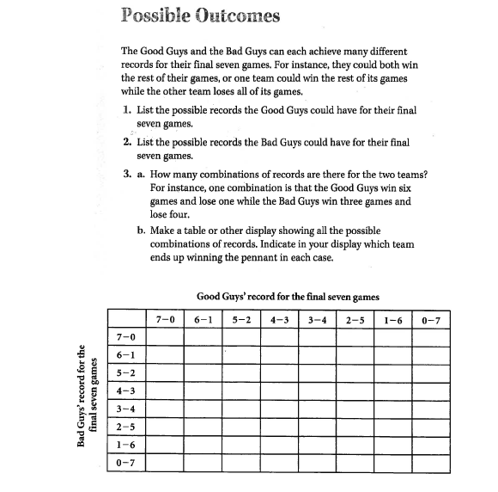

**How Likely is “All Wins”**

**Objectives:**

In this activity, students find the probability for multiple events occurring.

**Standards: 9.4.3.7, 9.4.3.8**

**Launch:**

Tell students that they will continue their investigation of the central unit problem by finding the probability that the Good Guys and the Bad Guys will each win all seven of their remaining games. Ask students which cell of the chart this case corresponds to.  
  
If students need a hint on Question 3, point out that the overall chart can be thought of as a not-to-scale area diagram and that Question 3 asks them to find the area of one of the rectangles in this diagram. Questions 1 and 2 give the length and width of that rectangle.

**Explore:**

Have a student report on Question 1, giving the group’s reasoning as well as the numerical answer. Ask if other groups have alternate explanations, trying to elicit both an area diagram and a tree diagram. Reasoning similar to that used in several recent activities should show that the answer is .627, which is approximately .0352.  
  
Once you have discussed Question 1 fully, you can probably simply get an answer for Question 2, skipping the discussion. The numerical value of .67 is approximately .0280.  
  
Question 3 involves putting these two results together to find the probability that both events will happen. This problem differs slightly from most of the recent problems because the results for the two teams do not form a sequence of events. This makes a tree diagram less natural as a model, and an area diagram perhaps more appealing.  
  
You can elicit that the probabilities would be the same if the Good Guys played all of their games before the Bad Guys played any of theirs. This may help students see that they should multiply the two probabilities in Question 3, as they have in other problems. This gives an overall probability of about .0352 • .0280, which is approximately .0010, for the outcome of both teams winning all their games.  
  
Ask, Which cell(s) in the chart from *Possible Outcomes* does this probability apply to? There is only one—have students identify this cell and enter the probability. That’s one down and 63 to go!  
**Summarize:**

Students may point out that if the Good Guys win all their games, then it doesn’t matter what the Bad Guys do. Therefore, as far as finding the Good Guys’ chances of winning the pennant, students don’t necessarily need to find the probability for every cell in the chart. However, we will find all the individual probabilities as the unit progresses for the sake of completeness.

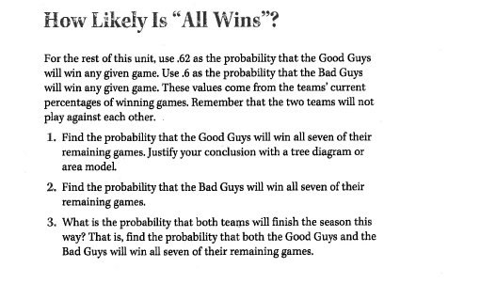

**Lesson:** Looking at the square of binomials and what the probability a male or female baby is born, Hospital Problem found on page 116 in Navigating through Probability in grades 6-8

(3 days)

**Objective:** Students will look at the probability that a male baby is born or a female baby is born. Students will also relate this to the square of a binomial. Students will understand that small samples may yield unusual or unexpected results. Recognize that the experimental probability approaches the theoretical probability of an event as the size of the sample increases.

**Standard:** NCTM standard 4.2: Students use proportionally and a basic understanding of probability to make and test conjectures about the results of experiments and simulations

Start by giving students the pre-test that is attached. The pre-test should take no more than 20 minutes.

**Launch**: My sister is having a baby my son thinks it is going to be a girl. We want to figure out the probability that she will have a girl and my son will be right.

**Explore:** Have students work on the two hospitals problem. This problem is found on page 116 in the Navigating through Probability in grades 6-8 book from NCTM. This problem talks about two hospitals keeping track of the gender of the babies born each day. Hospital A is a large urban medical center. Hospital B is a small regional facility. Many more babies are born each day in Hospital A than in Hospital B. It has students conduct an experiment to show the variability of small data sets to larger data sets. Students also need to collect data for a simulation of 25 births and compute the ratio of female births to total births and the experimental probability of female births. Students will also make a graph of x the trial number and y the experimental probability.

**Share:** Students will notice as the number of trials increases, the variability in the data would be expected to decrease. Students will also see that the experimental probability of having a female baby is close to 50 percent.

**Explore:** Students will look at the probability of 3 different people having 2 boys. I will have students first look at the probability of a person having 2 boys. Students should realize that there is an equally likely probability a person has a boy or a person has a girl. I would have students see if they can come up with the probability on their own.

**Share:** I would have students write on the board what they found. Students may come up with a sample space of BB BG, GB and GG. They then would see that there is a ¼ chance of having 2 boys. I would see if students could come up with an area model to represent this. Students hopefully would come up with something like below.

B G

|  |  |
| --- | --- |
| BB | BG |
| GB | GG |

B

G

I would tell students that people call the above area model a Punnett square and Punnett squares are squares to show the possible ways that genes can combine during fertilization. We would have already talked about polynomials and how to multiply polynomials. I would see if students could come up with a way to tie the above area model into the square of two binomials. Hopefully students would come up with something like there is a .5 chance that a baby is a boy so .5B and a .5 chance the baby is a girl so (.5B+.5G)2 could represent the probability. When I multiply the binomial squared out I end up with 1/4B2+1/2BG + 1/4G2. Which shows the same information as the above Area model does.

**Explore:** Taking probability a step further. I want you to think of the probability that Ali and Becca will have two boys given that Ali’s first child is a boy and for Becca you know that 1 is a boy. More information can change the probability. You can still look at the area model and the written out sample space to help you.

**Share:** Students should be able to see looking at the area model that there are 2 times out of 4 that a boy shows up 1st. So the P(Ali has 2 boys given her 1st is a boy) is ½. Students should notice that there are 3 times that a boy shows up in the sample space but only 1 of them is when there are 2 boys so the P(Becca has 2 boys given that 1 is a boy) is 1/3.

**Summarize:** If I go back to my question at the beginning of my sister is having a baby and my son thinks it is a girl. What is the probability it is a girl? Hopefully students would say she has a 50/50 chance. Now let me make you think harder. What is the chance she has a girl if her first child was a girl? Hopefully students would say she still has a 50% chance.

**Analyze/Assess:**

Pre/Post Test:

In pea plants, the gene G is for green pods, and gene y is for yellow pods. Any gene combination with a G results in a green pod. Remember you can either have a Green Pod or a yellow pod.

Can you come up with the percent of possible gene combinations the plant will result in a yellow pod?

How about the percent for a Green pod?

Draw an area model to help show the probability of each combination.

Show how you could use a polynomial to model the possible gene combinations.

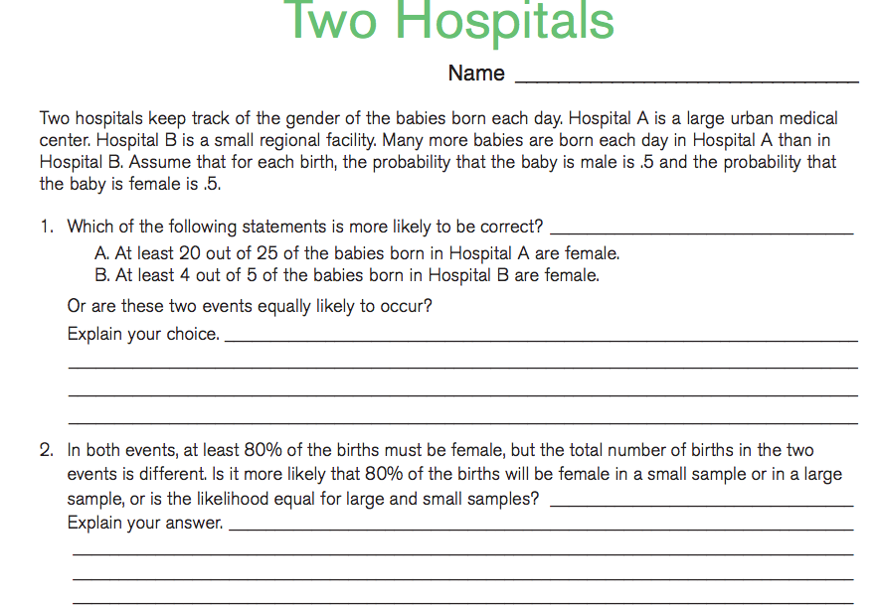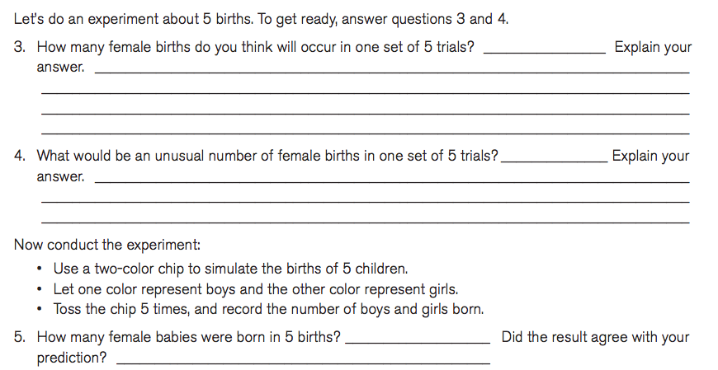

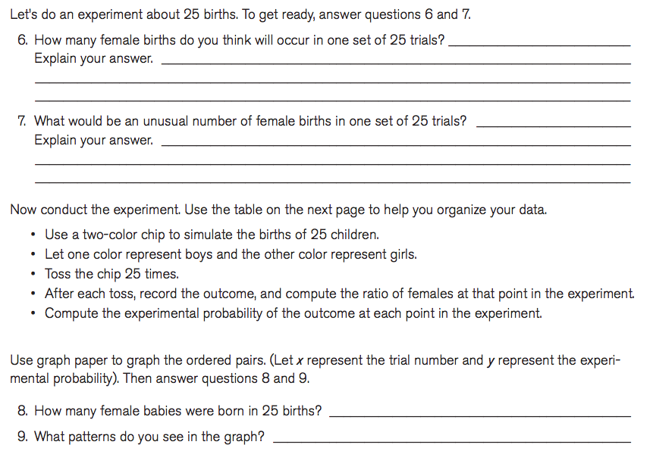

10. Answer question 1 again is your answer the same or different? Explain.

Two Hospitals was taken from Navigating through Probability by NCTM.

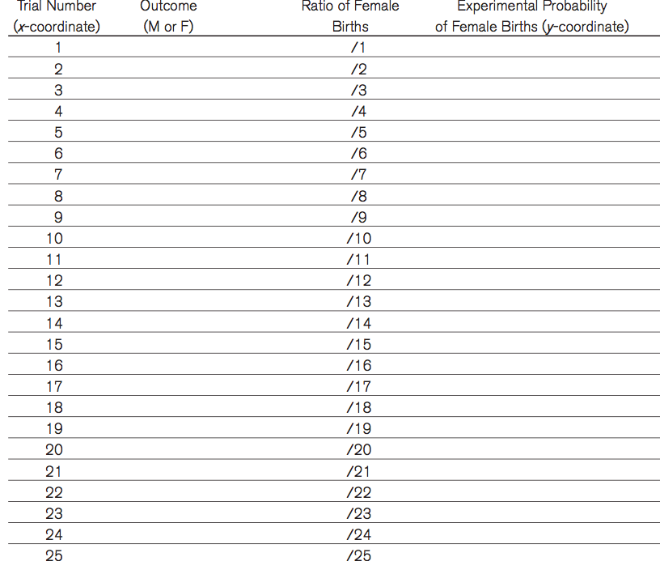

**Lesson:** How black is a Zebra? This activity is found on page 128 in the Navigating through Probability in grades 6-8 from NCTM.

(2 days)

**Objective:** Use a random-number generator to determine the coordinates of random points.

Most 8th graders have plotted points in the coordinate plane. All students need a refresher though so this lesson would help them review how to plot a point in the coordinate plane.

Students would also explore the importance of sample size when making a prediction or estimate.

**Standard:** 6.1.1.1 Locate rational numbers on a coordinate grid.

**Launch:** We just got back from the Minnesota Zoo. My son loved looking at the Zebra. I asked him what color the zebra was. He said white, and then he said black. I said well he is white and black. I then thought I wonder if the Zebra has more black or more white? I told my son my class would help us answer that question!

**Explore:** Students are going to use a random-integer function on a calculator to generate pairs of numbers from 1 – 30. The first number designates the x-coordinate of a point, and the second number designates the y-coordinate of that point. Students will determine where each point is on the Zebra picture. If the point happens to not be on the Zebra students will generate a new point. Students will record their data on the recording sheet found on pg 128 in the Navigating through Probability in grades 6-8 from NCTM. Students will put an x in the last column if they landed on a black part and they will leave the line blank if they landed on a white part. Students will do this 10 times and figure out the percent of the points on a black part. They will then try to estimate the percent of the zebra is black and if their estimate is accurate. Students will then do this 20 more time and again estimate the percent. We will also collect the classes’ data to see if that would help us find the percent the zebra is black.

**Share:** Students should share their data and their predication of how black the zebra is. Students should also see that the more data they have the more confident they could be with their answers.

**Summarize:** How Black is a Zebra? Can I tell my son he is more Black or more White? What did you learn about sample size? Could I make a good prediction when I only did this 10 times?

**Analyze/Assess:**

**Pre/Post Test:**

Graph the following points in the coordinate plane.

1. (5,10)
2. (12, 15)
3. (-4, 10)
4. (5, -12)

If I want to use a sample space to make a prediction would more or less trials help me make an accurate prediction?

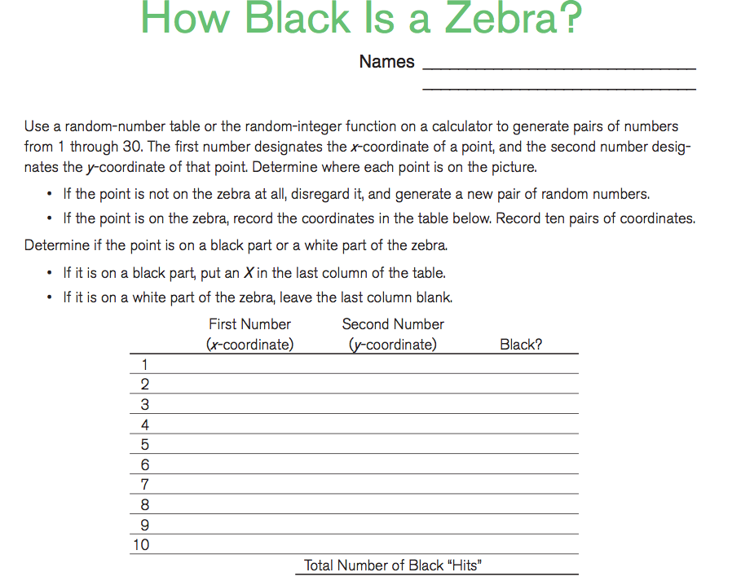

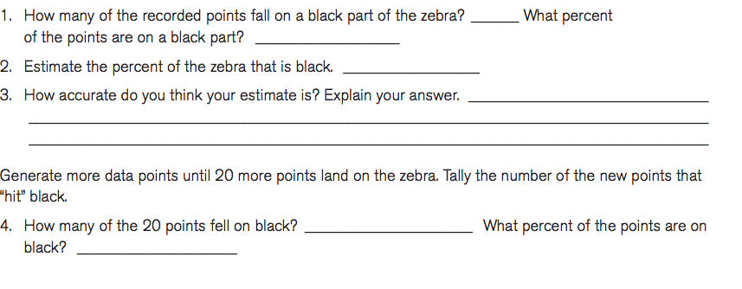

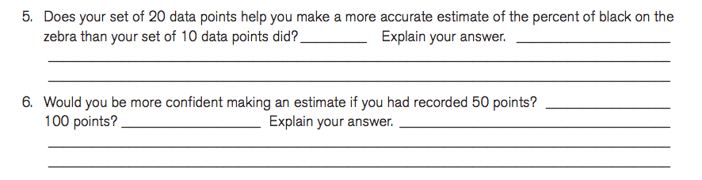

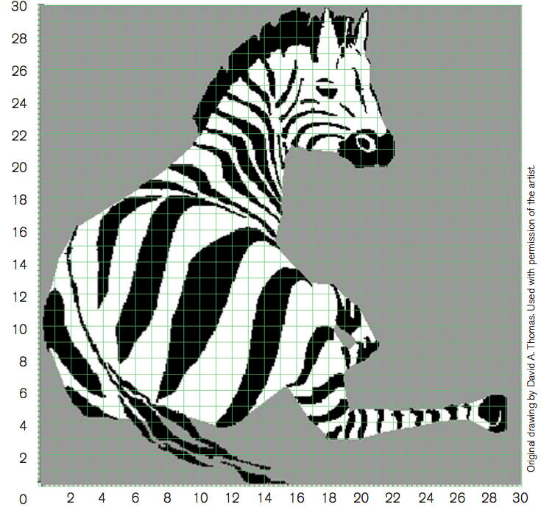

**The lesson above is taken right from Navigating through probability from NCTM.**

Introduction to Expected Value

1 day

**Standard:** 9.4.3.8  Apply probability concepts to real-world situations to make informed decisions.

**Launch:**

Teacher will present this as a carnival game, and ask the students to each play 30 rounds (keeping track of the results:

***Rules to my game:***

**Two** tickets to play

If your sum in one roll is **2,or 3** then you get 4 back. (**You win 2 tickets**)

If your sum in one roll is **4 or** **5** then you get 3 back. (**You win 1 ticket**)

If your sum in one roll is **6 or** **7** then you get 2 back.

If your sum in one roll is **8 or** **9** then you get 1 back.

If your sum in one roll is **10,11 or 12** then you get 0 back.

**Explore**:

Activity 1 Students will play the game keeping track of the results (the tickets can be real or fictitious).

Activity 2 Students will be asked to create a sample space and find the probability of each event.

**Share**: Students will share the result of the game, and discuss whether they would want to play this game for real over a long period of plays. The class will discuss the possible outcomes from a perspective of gain: You win 2 tickets/ 1ticket/ Break Even/ Lose 1 ticket/ Lose 2 tickets

**Summarize**: Students will discuss with teacher the idea of an expected value, and how probability will affect expected value.

How to Calculate Expected Value

1 day

**Launch:** Teacher will remind them of the game from the previous day, and have a discussion of whether or not it was fair. They will also review the probabilities of each event.

Activity 1 Teacher will lead the class in a discussion of what a fair game is.

**Explore (in groups of 3):** Teacher will give this chart and the rules to the game and have students calculate the gain of each possible outcome times the probability of each possible outcome. Then the students will be asked to interpret what it means.



**Share:** If student groups have different results and/or interpretations the class will discuss, and along with teacher come to a consensus on the results and the meaning of the results.

**Explore:** Teacher will then give a completed expected value chart and ask student groups to come to a consensus about what the sum represents, and how to interpret a (+) or (-) summation.



Students will decide if the game was a fair game or not based on the expected value, and try to find in groups a change to the rules that would make it fair or more closely fair.

**Summarize:** Teacher will conclude with the students reviewing what makes a fair game, and what the expected value would be of a fair game. They can also discuss advantage. They should be able to summarize how to find gain, and what the products of gain times probability added up represent. Teacher can use the sentence “over a long time of many plays you should expect that on average the gain is … .”

Creating a game and finding the expected value of the game.

**Launch:** Teacher will present the geometric game and review the concepts of expected value.



|  |  |  |  |
| --- | --- | --- | --- |
| Gain x | P(x) | xP(x) |  |
|  |  |  |  |
|  |  |  |  |
|  |  |  |  |
|  |  |  |  |
|  |  |  | Expected Value |

**Explore:** Students will be asked to create a game of chance. Create the rules to go with the game, and construct an expected value chart. Students will then take turns playing other students game (at least one other) ten times, and give an opinion as to whether the expected value predicted correctly the average gain over many plays.

**Share:** Students will share what they struggled with and what they learned from the lesson.

**Summarize:**

Probability in Contrast to Odds

1 Day

Launch: Review the definition of probability of a favorable and unfavorable event

Introduce the definition of odds for and odds against.

**Explore:**

Activity 1 Given the following grid for a game, have groups of two or three students calculate the odds for and the odds against.



Activity 2 Teacher should ask students to find a way to simplify the process.

Activity 3 Teacher will ask them to calculate the odds for and against the game the students created on the day previous. And them to then evaluate if it is even odds or not (a discussion of a fair game review may be appropriate).

**Share and Summarize:**

Payoff Odds of a Fair Game

1 Day

**Launch:** This game requires you to pay $1 to play. When you play you slide a token and try to land it on a $2 square (whichever square it is more one is the one you count it to be on). A person is claiming that it is Even Odds. Do you agree or disagree? ___________________



Teacher will explain that if a game is not even odds, it can still be fair as long as the payoff odd (ratio of amount paid out to amount paid in) is the same as the odds against.

**Explore:** Teacher will have them calculate the payoff odds for a fair game to would accompany this “dart game”.

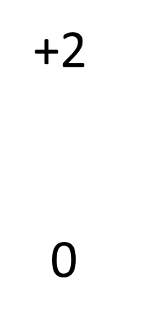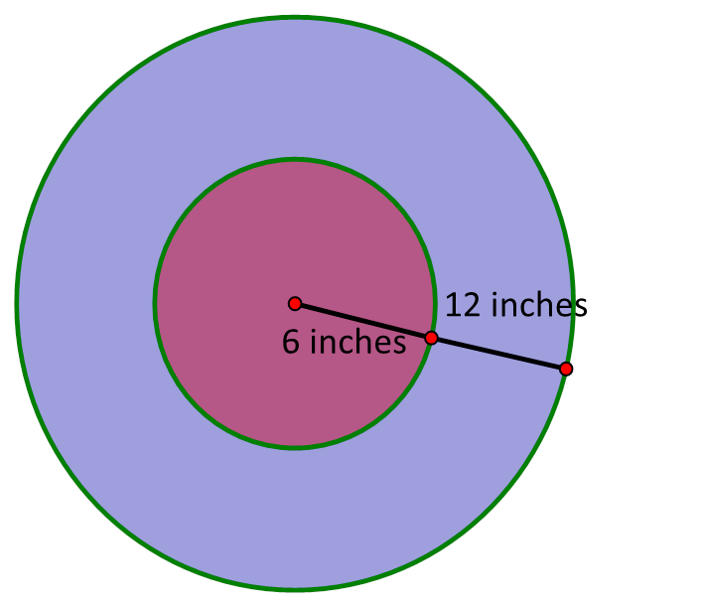

**Share and Summarize:**

PreTest/Post Test Questions

1. If this is the expected value table for a game, is it a fair game? __________



1. A game consists of a bucket that has 8 marbles in it 2 red and 6 blue. If you win by selecting a red marble:
2. What are the Odds For? _____________
3. What are the Odds Against? _____________
4. What are the PayOff Odds? _____________
5. If this is a “slider” game, what is the expected value of the game? ________________



1. How do you interpret the expected value? ____________________________________________________________________________________________________________________________________________________________